**Shoulder Movement Sensing System for Robotic Hand Control**

This Undergraduate student project developed a system to control the operation of a robotic hand using shoulder movements.

Presented By:

[Nitay Ozer](mailto:nitay.ozer@campus.technion.ac.il?subject=Robotic%20Hand%20Control%20via%20Shoulder%20Movement) – [nitay.ozer@campus.technion.ac.il](mailto:nitay.ozer@campus.technion.ac.il) , 050-3911131

[Itay Mal](mailto:itay.mal@campus.technion.ac.il?subject=Robotic%20Hand%20Control%20via%20Shoulder%20Movement) – [itay.mal@campus.technion.ac.il](mailto:itay.mal@campus.technion.ac.il), 050-3807171

Supervised By:

[Kobi Kohay](mailto:kohai@ee.technion.ac.il?subject=Robotic%20Hand%20Control%20via%20Shoulder%20Movement) - [kohai@ee.technion.ac.il](mailto:kohai@ee.technion.ac.il), 052-3457049

Git link - <https://github.com/itay-mal/robotic_hand_project>

[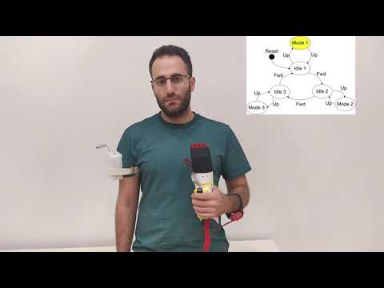](https://www.youtube.com/embed/S5bqmxKfQ3U?feature=oembed)